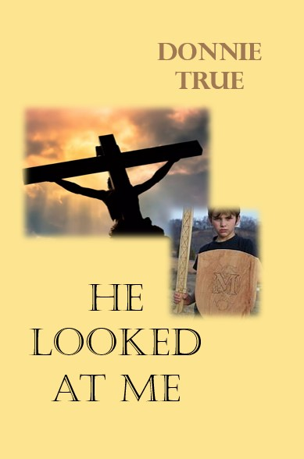FOR IMMEDIATE RELEASE

**He Looked at Me** by **Donnie True**

**FICTION / Christian / Historical**

Dateline: Fort Meade, FL April 15, 2023 **(ShelteringTree.Earth) –**

ShelteringTree.Earth, LLC is proud to announce the publication of Donnie True’s **He Looked at Me** in Kindle, trade paperback, and hardcover, available through Amazon and other fine bookstores.

Marcus was the child of an innkeeper, but he had man-sized dreams of becoming a centurion. His father was THE innkeeper – the one who let Mary and Joseph stay in his stable – the stable Marcus kept clean.

Would Marcus become a man who was feared and respected because of his position, or a man who became what God wanted him to be – the centurion at the cross of Christ?

**He Looked at Me** is a fiction about a real story. Included are discussion questions and illustrations to help facilitate small group studies.

**About the Author**

Donald Ray True is a Husband, Father, Son, Grandfather, and Brother. He grew up in a Christian home with Godly parents. He asked Jesus into his heart when he was 27 years old. He taught Sunday School for many years at Fort Meade First Baptist Church. He was inspired to write this story because of the centurion at the cross of Jesus who began to shout and sing praises to God after he realized who Jesus was, to get people thinking about what really happened that day and what happened to the centurion afterwards. Donnie truly believes he was a changed man. He hopes you enjoy this story, and it inspires you to read your Bible more.

Donnie True is a resident of central Florida and is available for interviews, discussion groups, book signing events, and would be honored to speak with any local civic service group, religious organization, or business about Christianity. To set up interviews, speaking engagements, or book signing events, please contact the author through the author page on https://shelteringtree.earth/

**About Sheltering Tree . Earth, LLC**

We are an exclusive traditional publishing house specializing in *books which help you feed His sheep*. We publish fiction, nonfiction, juvenile, and poetry.

Evelyn Rainey, Publisher

ShelteringTree.Earth, LLC Publishing

Friend@ShelteringTree.Earth

https://shelteringtree.earth/

# # #